Appendix 1: Assignment submission cover sheet
ASSIGNMENT SUBMISSION COVER SHEET

CSE25-300
Student Id:

KGOSI MERAPELO SELELO
Student names:
CSE25-300@thuto.bac.ac.bw
Student email:

Cohort: 2026

SCIS WMD_2026 A01
Assignment title:

21\05\2026
Date of submission:
COMPUTER SYSTEMS ENGINEERING
Programme of Study:

YEAR 1
Year of Study:

Intellectual property statement
By checking the box below, I certify that this assignment is my own work and is free from plagiarism. I understand that the assignment may be checked for plagiarism by electronic or other means and may be transferred and stored in a database for the purposes of data-matching to help detect plagiarism. The assignment has not previously been submitted for assessment in any other unit or to any other institution. I
have read and understood the Botswana Accountancy College plagiarism guidelines policy.
YES☐ Agree Signature…K.SELELO………………………………….
Date……21/05/2026…………………………………….

KMS LOANS ENTERPRISE

1.WEBSITE SPECIFICATIONS

KMS LOANS ENTERPRISE website is designed to provide an online platform that simplifies access to student loans by allowing students to easily apply, track and manage their loans online.

BUSINESS GOALS OF THE WEBSITE

1.Increase accessibility to loan
-Enable students to apply for loans anytime and anywhere
2.Modernize loan applications process
-Replace manual forms with an online application system
3.Enhance customer experience
-Allow students to track applications status in real time
4.Promote the KMS LOANS ENTERPRISE brand
- Build credibility and trust in the loan service

TARGET AUDIENCE
Primary audience; university students
Age ;18-30
Location; Gaborone
Occupation; Full time students
Technical aptitude; Basic to average digital skills ( comfortable using smartphones and computers)

TYPE OF WEBSITE; FINANCIAL SERVICE WEBSITE

2. INFORMATION DESIGN AND TAXONOMY

HOME PAGE
-Apply for loans
-Loans status
-Repayment
-Contact
-Feedback

APPLY FOR LOANS PAGE
-Application requirement
-Upload documents

LOAN STATUS PAGE
-Check application status
-Approved loans

REPAYMENT PAGE
-Payment methods
-Loan balance

CONTACT PAGE
-WhatsApp number
-EMAIL

FEEDBACK PAGE
-Comments

3. PAGE TEMPLATE DESIGN

- LOW FIDELITY

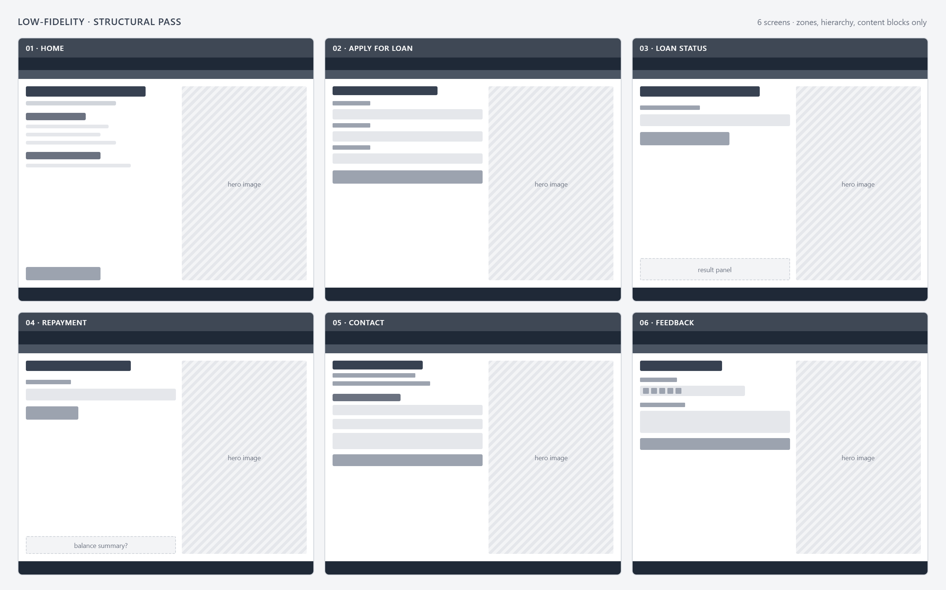

b. HIGH FIDELITY

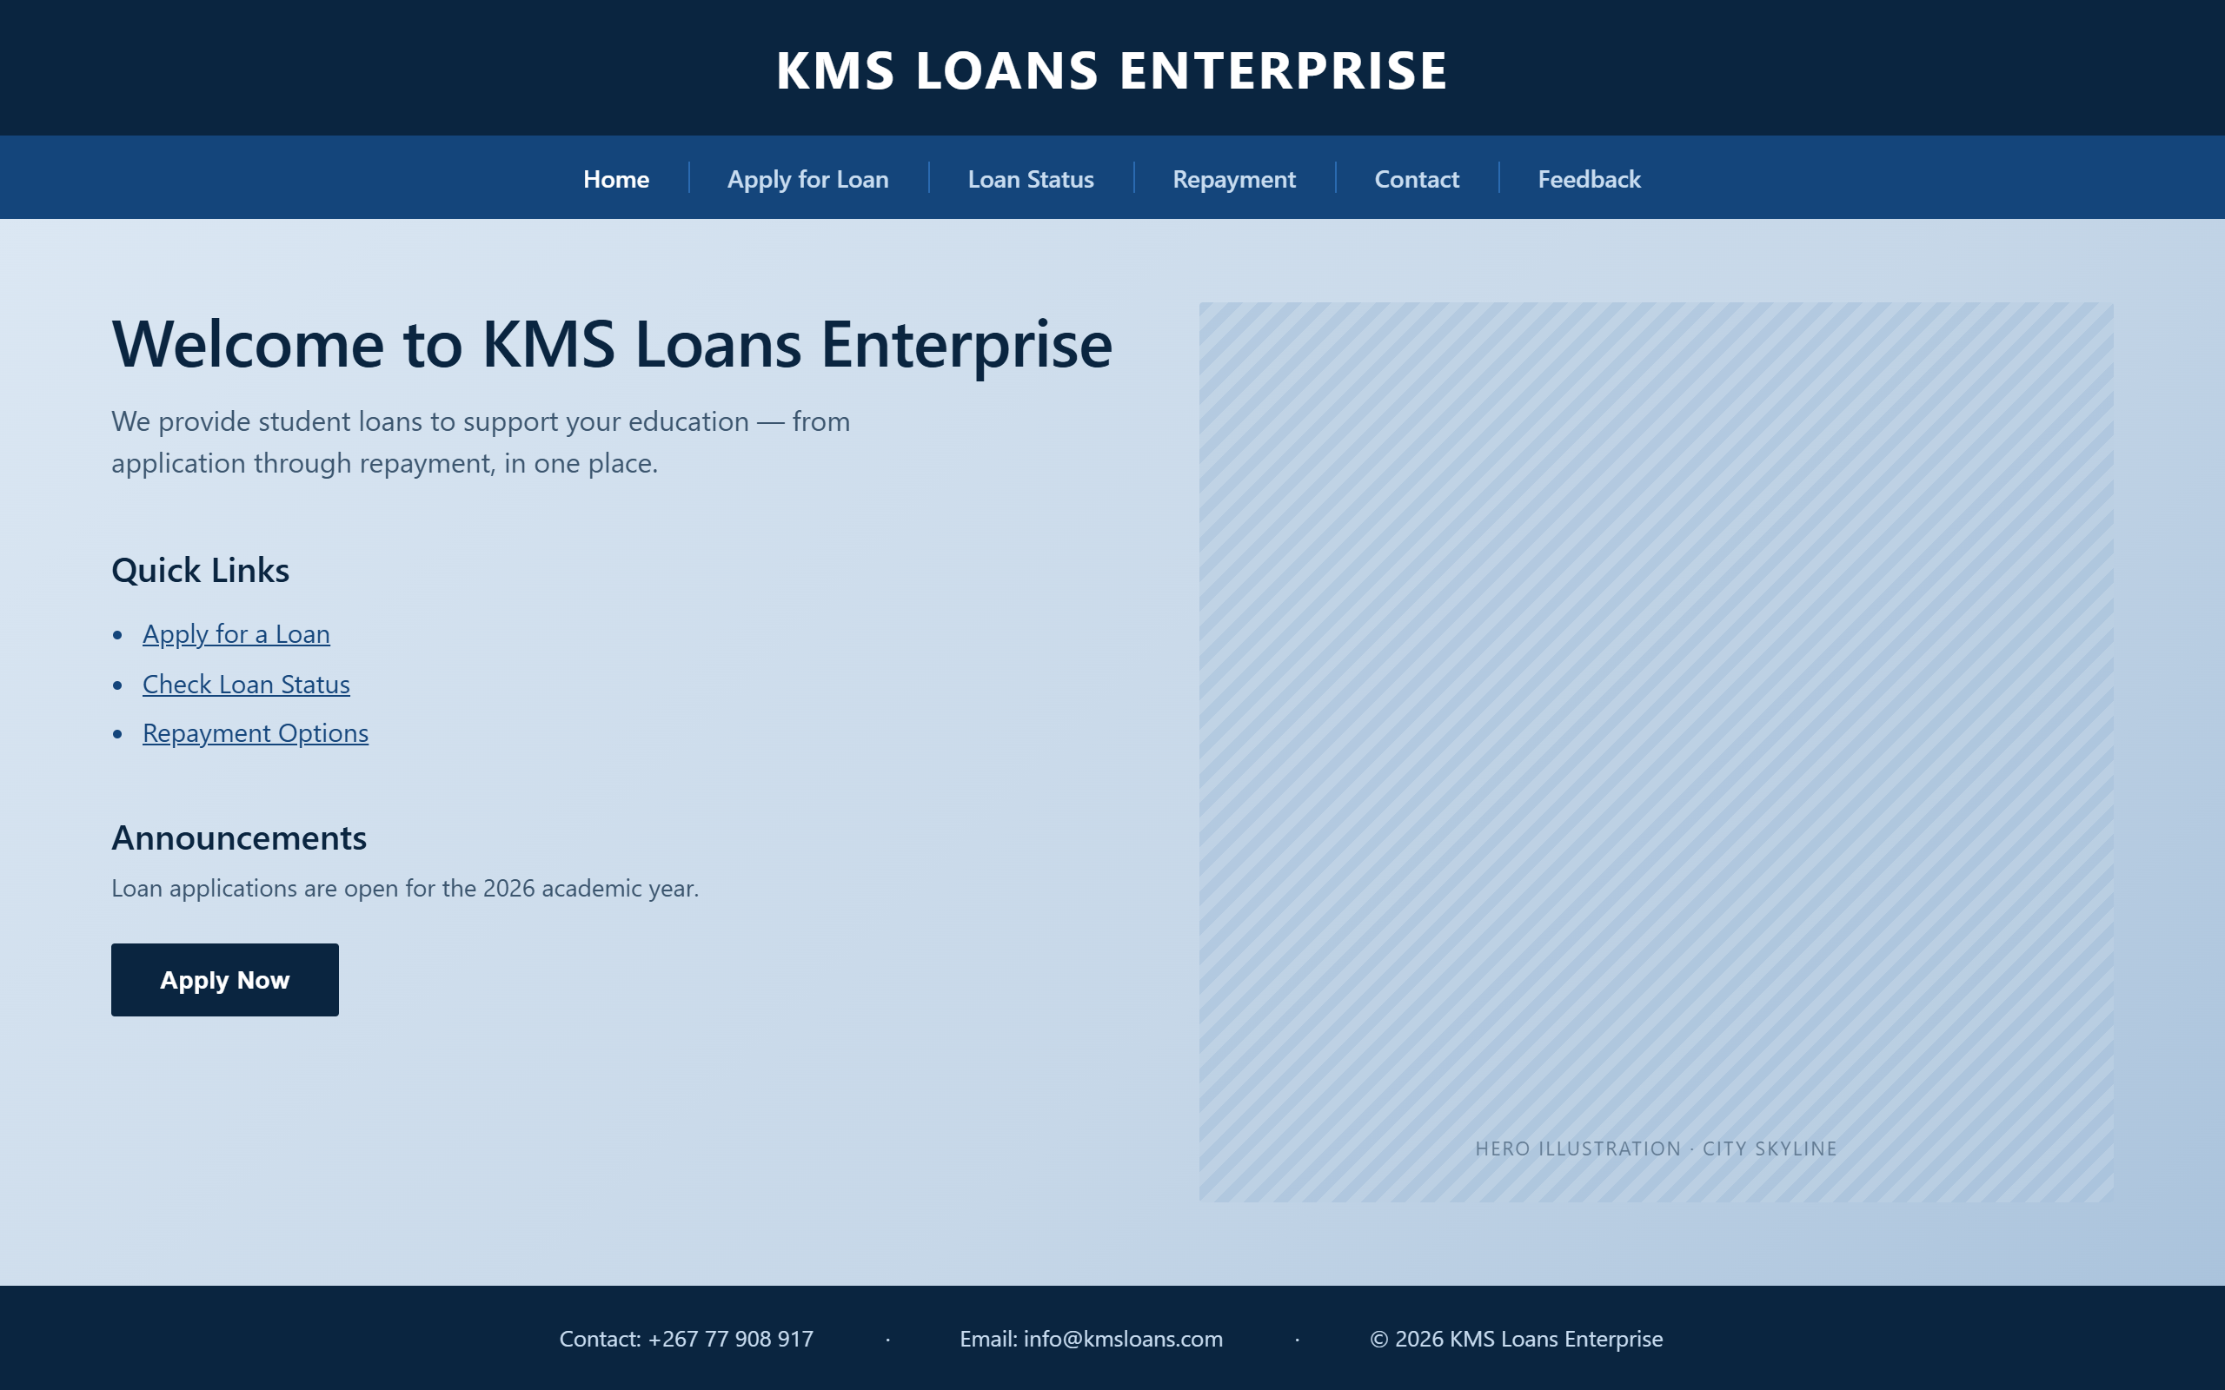

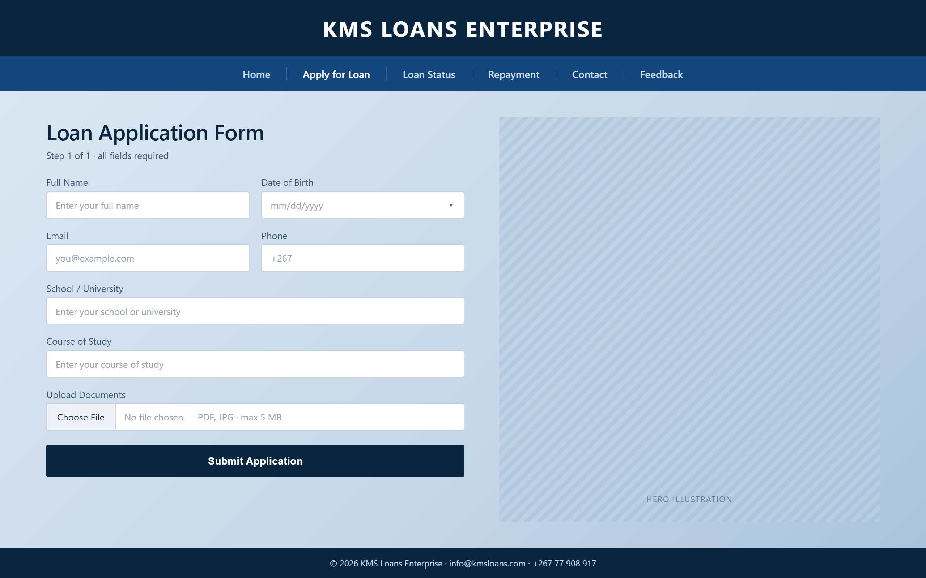
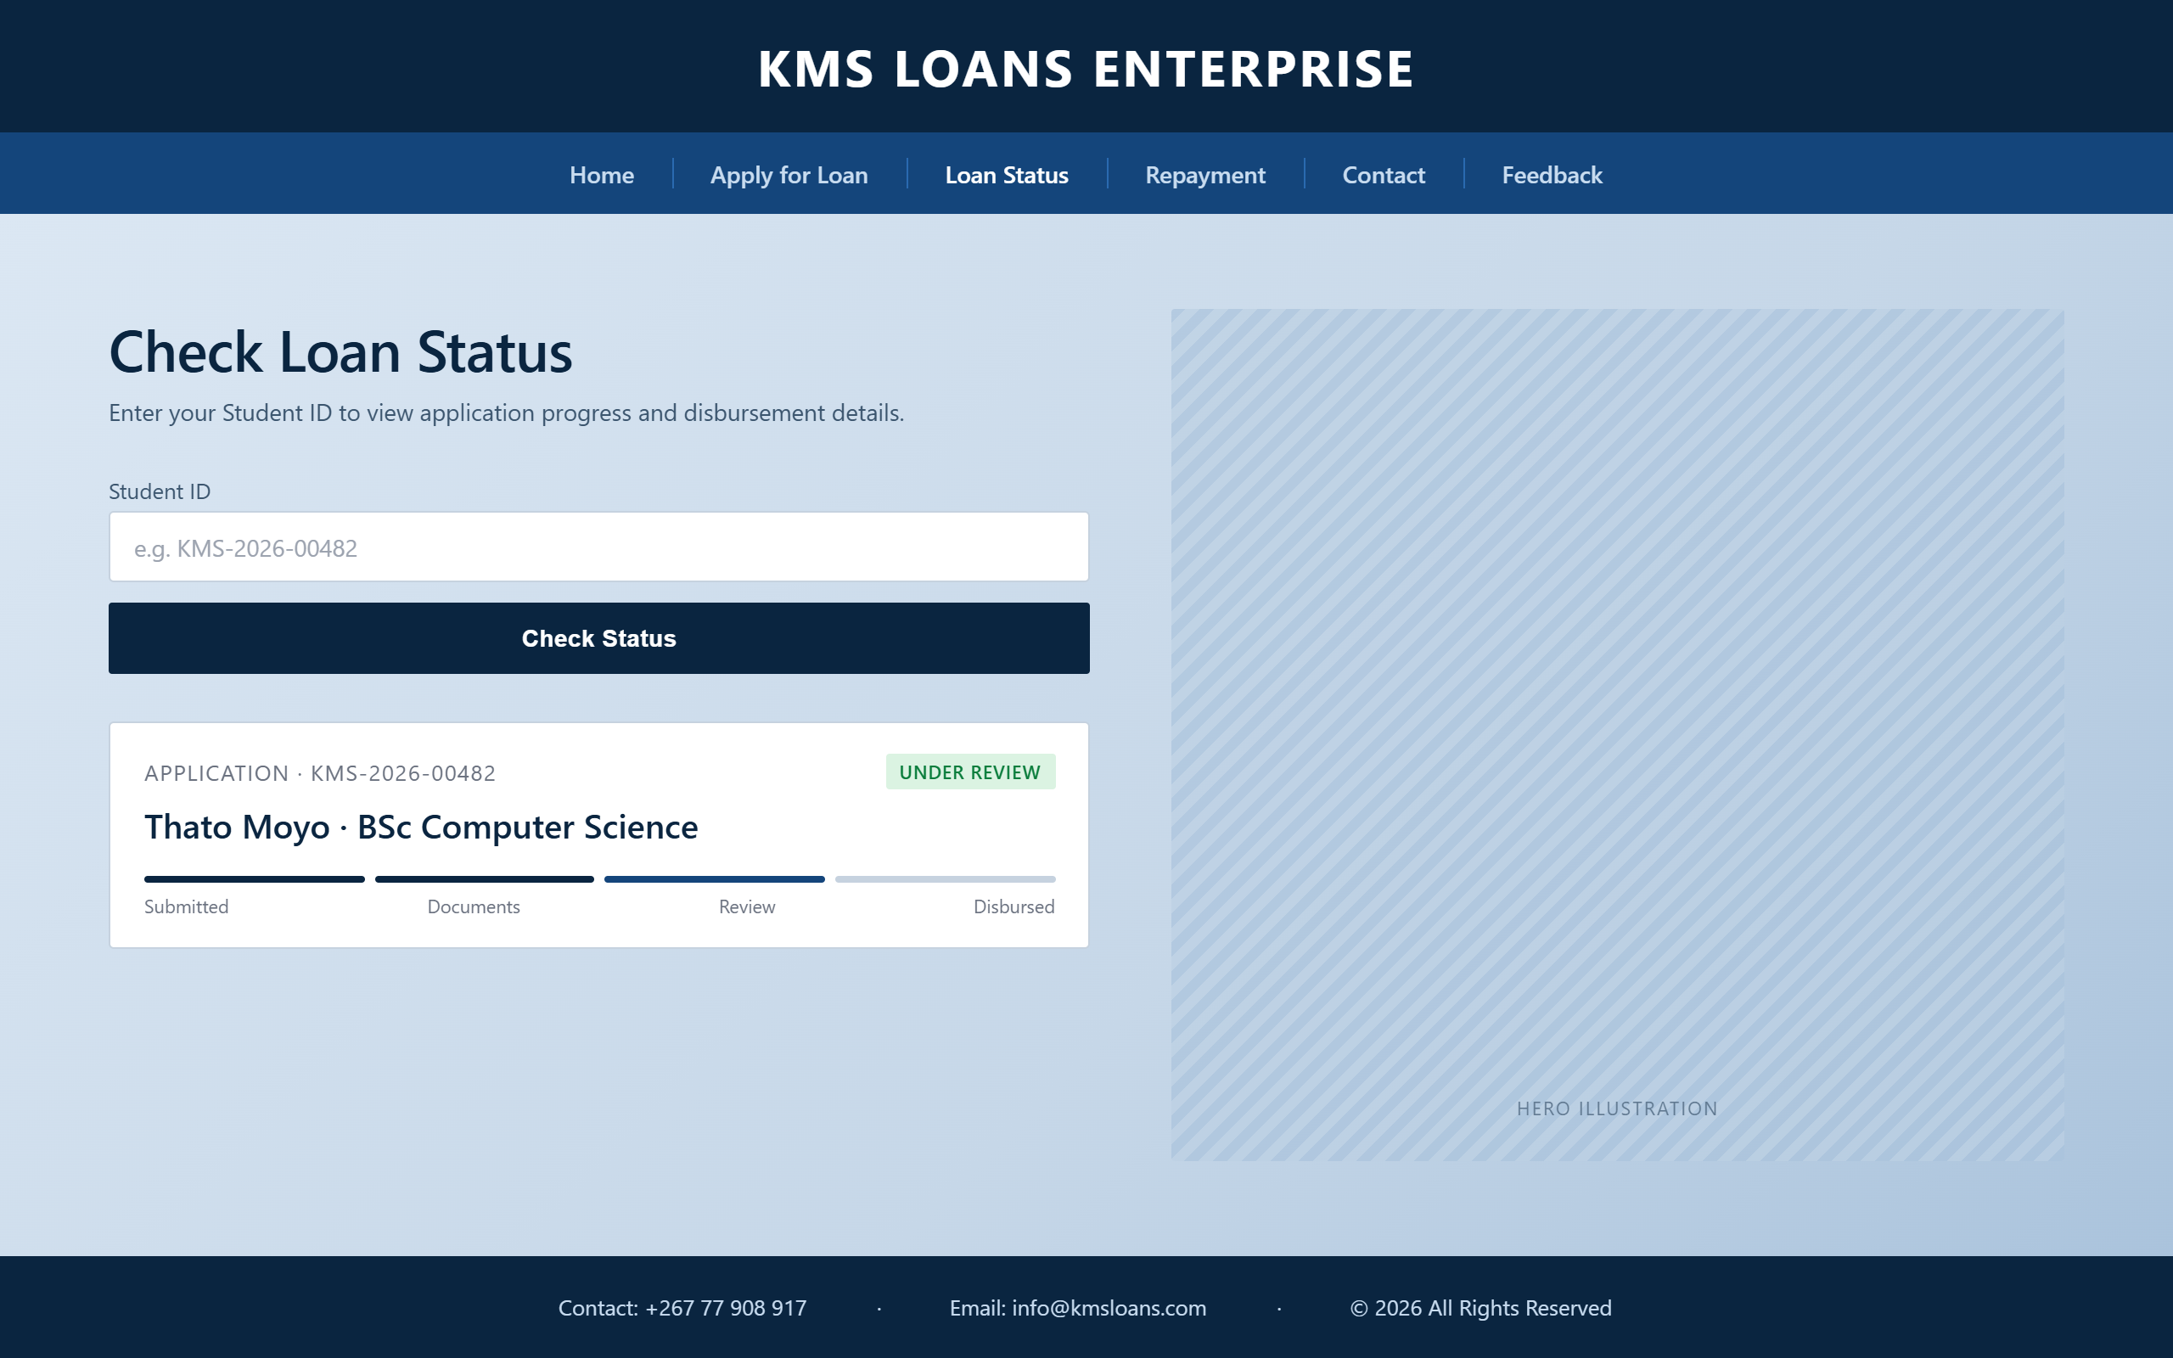
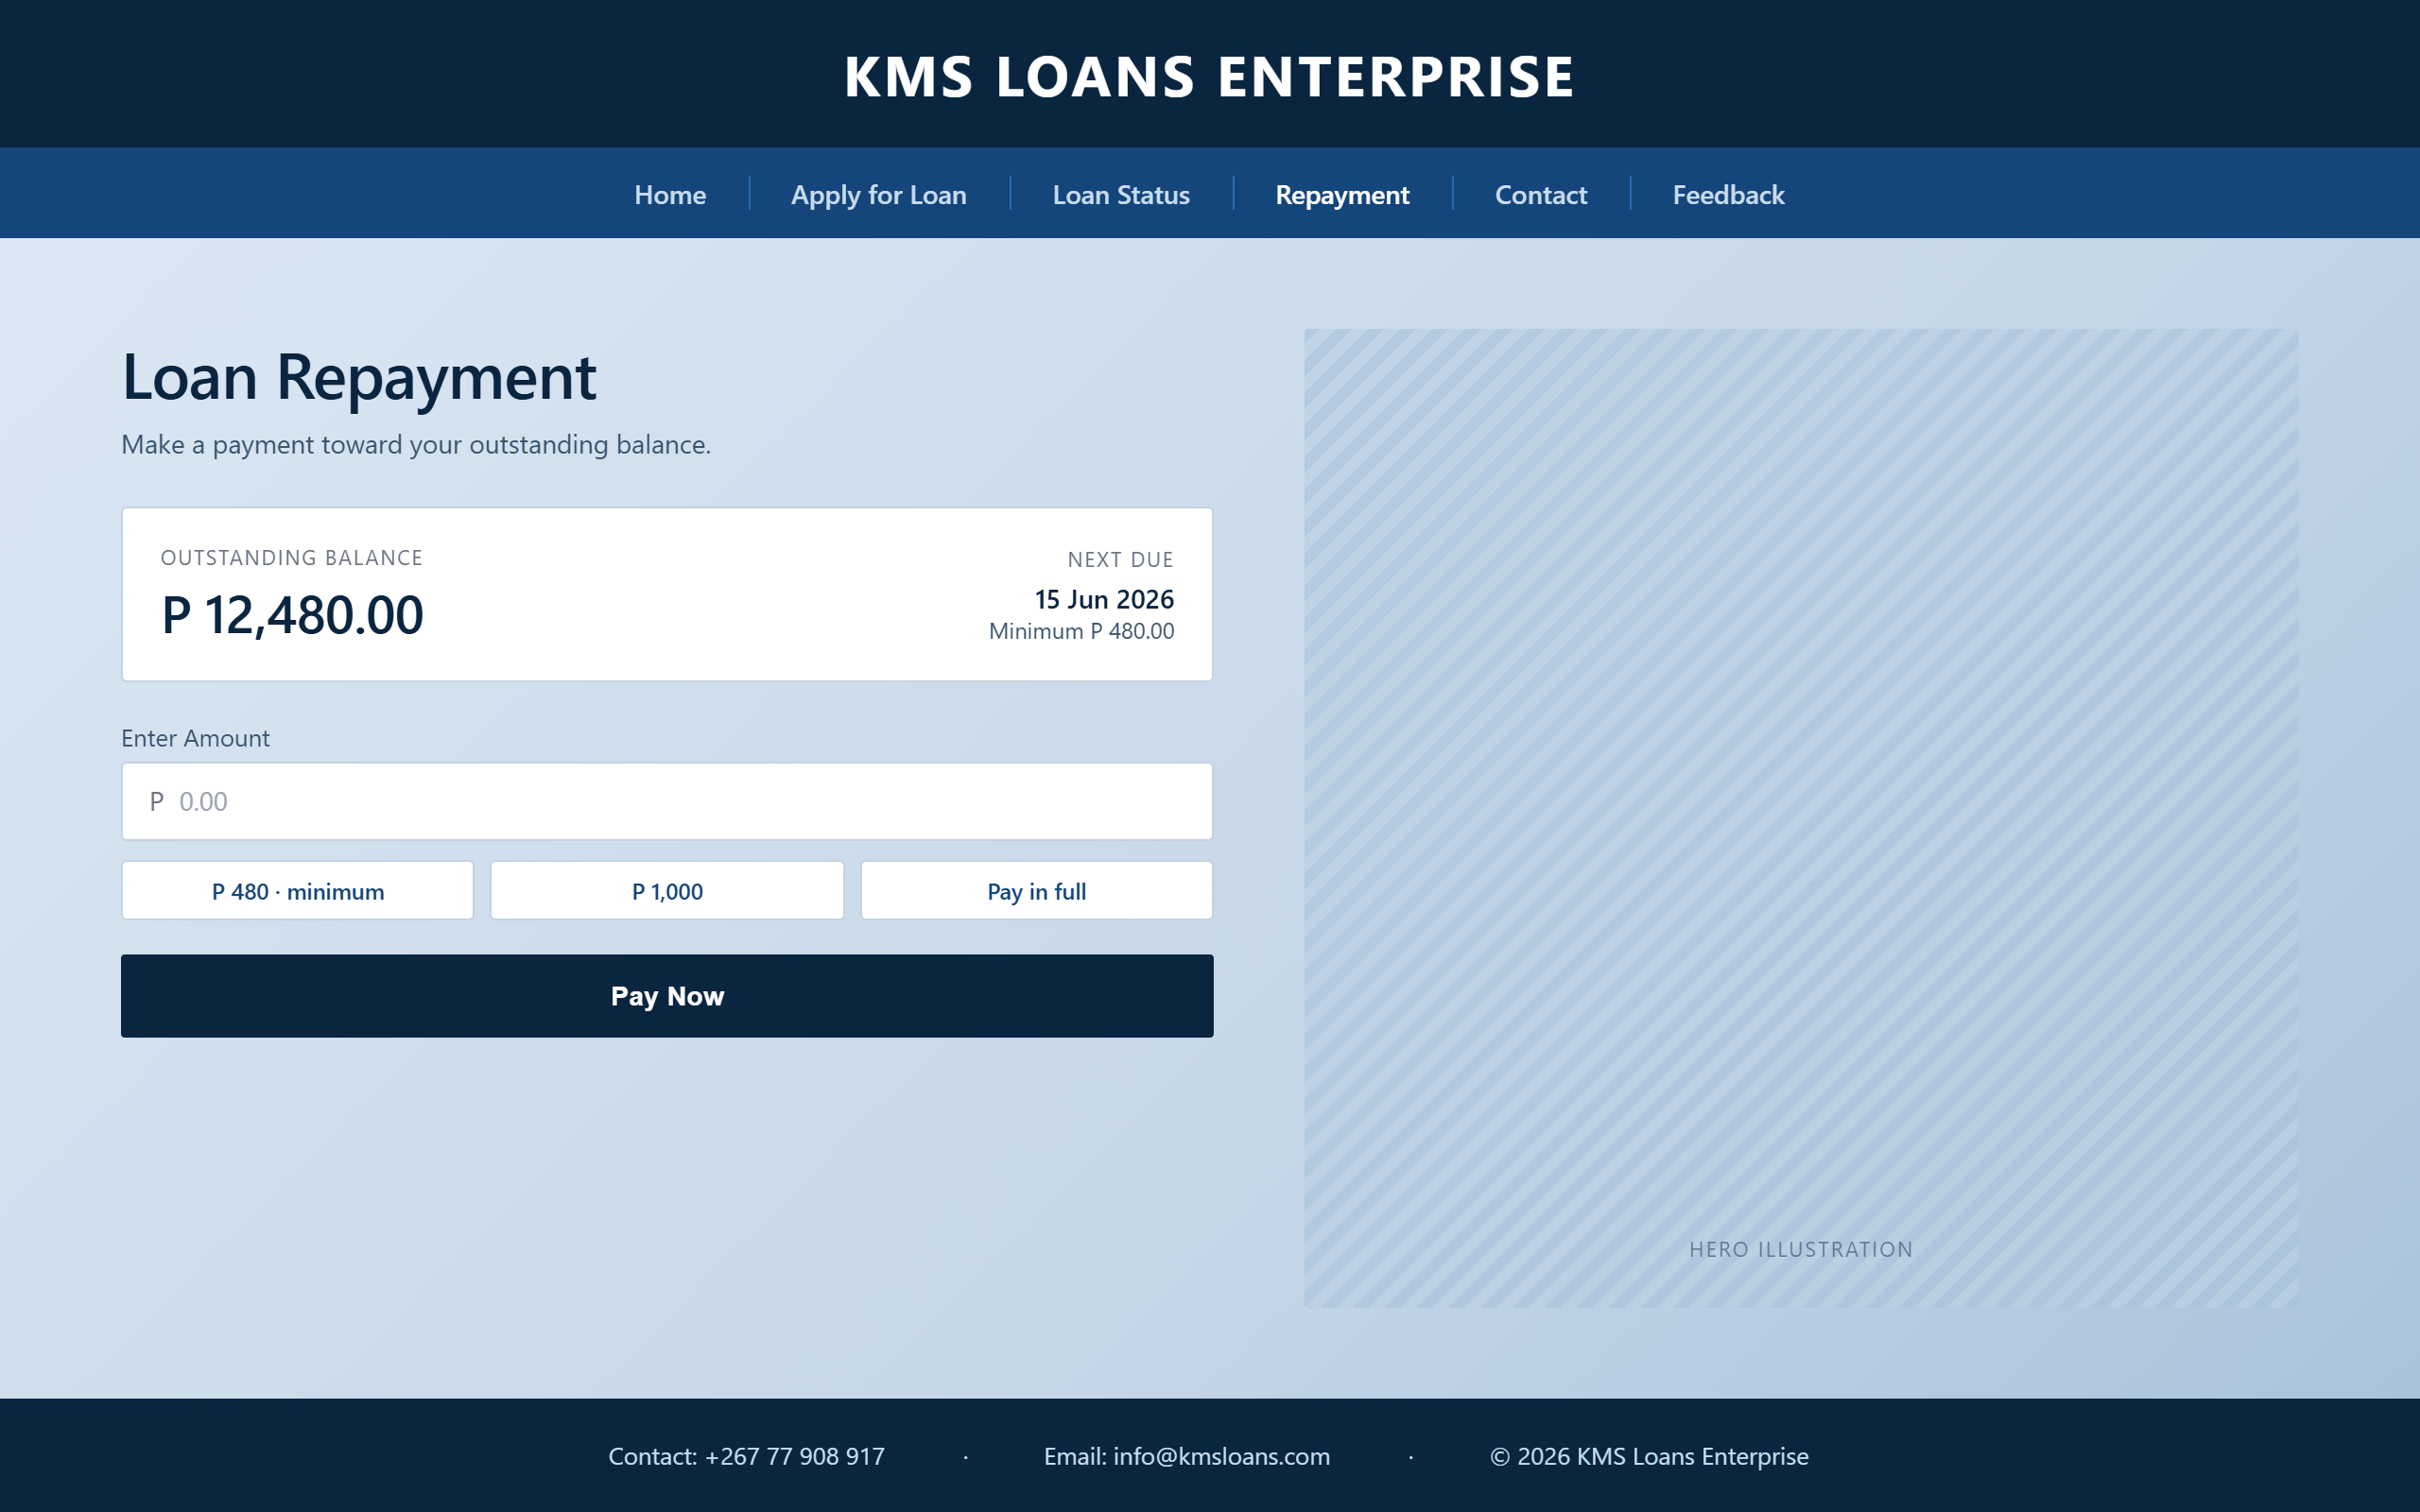
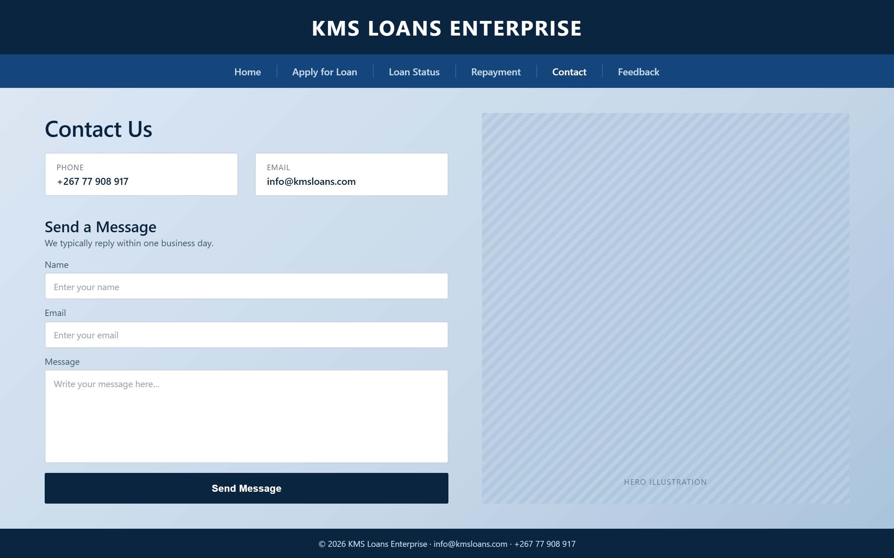
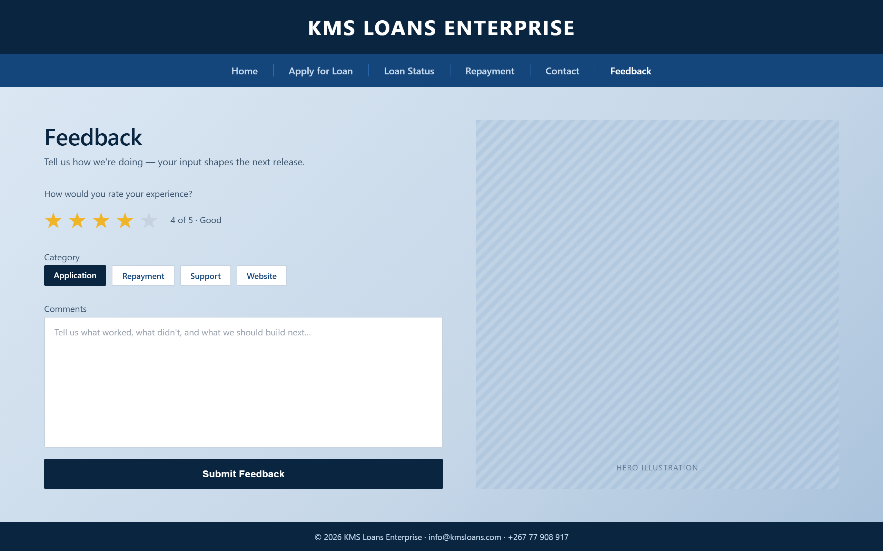

4. TECHNICAL BRIEF

The following technologies were used during development:

- HTML5
-Structure of webpages

B .CSS3
Styling and layout

C.BOOTSTRAP5
Responsive design

D.JAVASCRIPT
Interactive functionality

E. GITHUB
Project hosting and version control

- . QUALITY ASSURANCE

- MOBILE TESTS

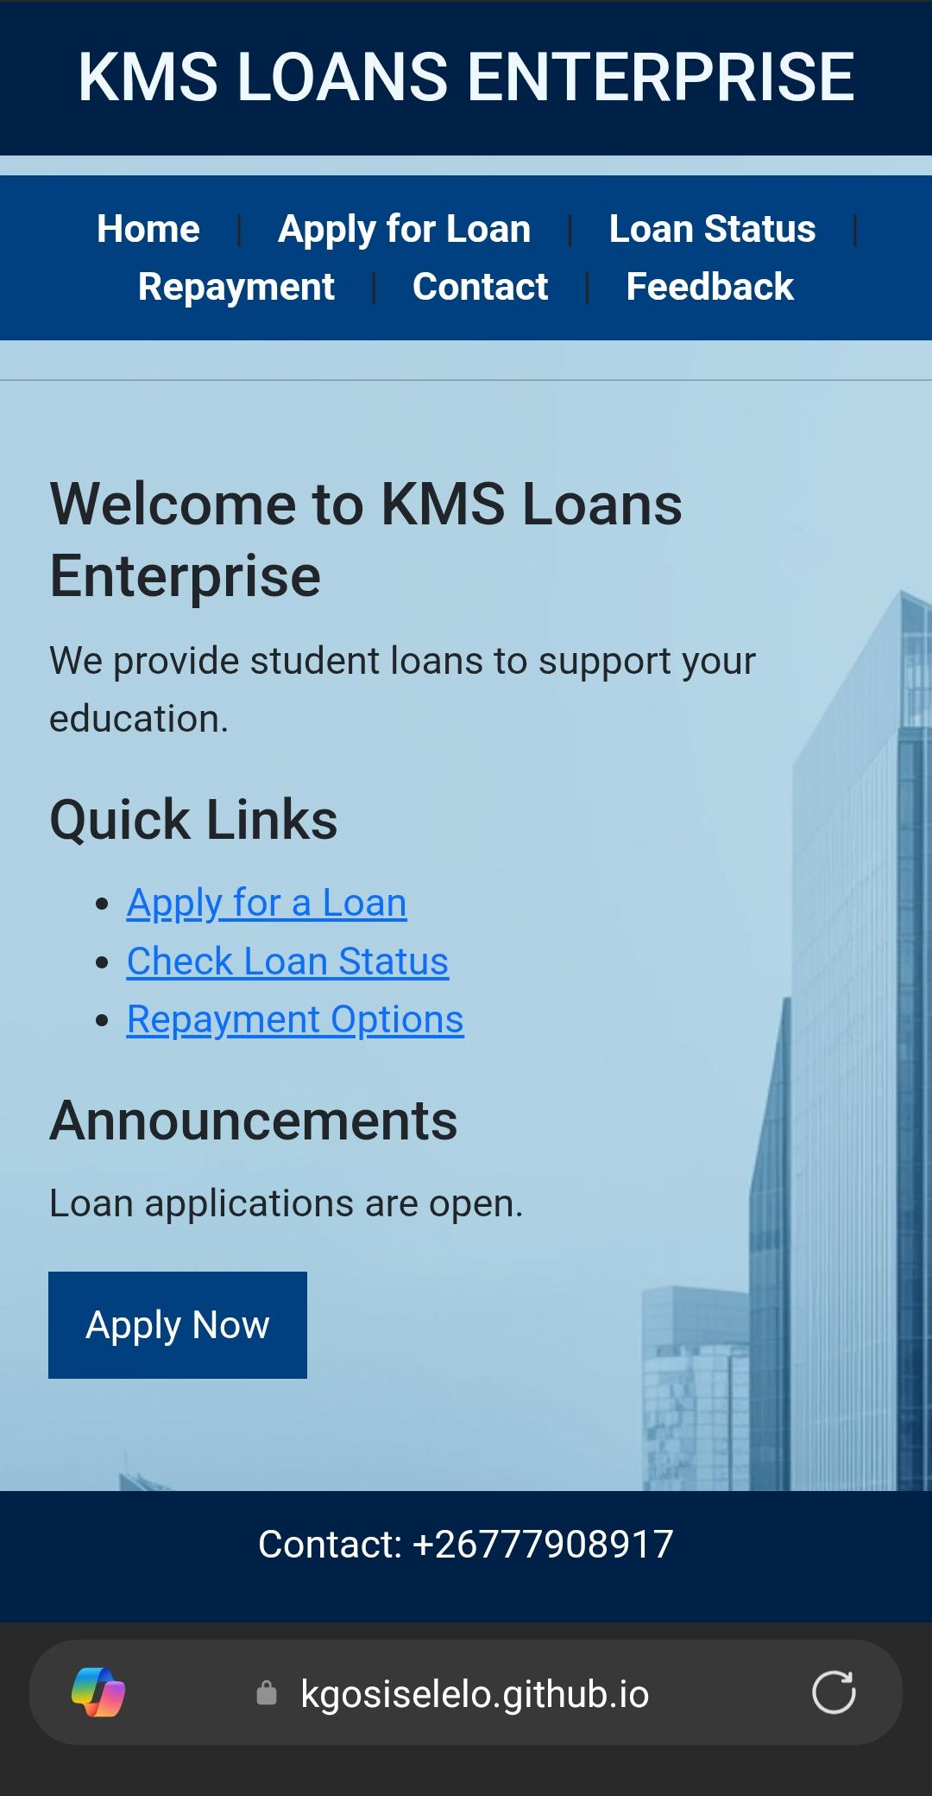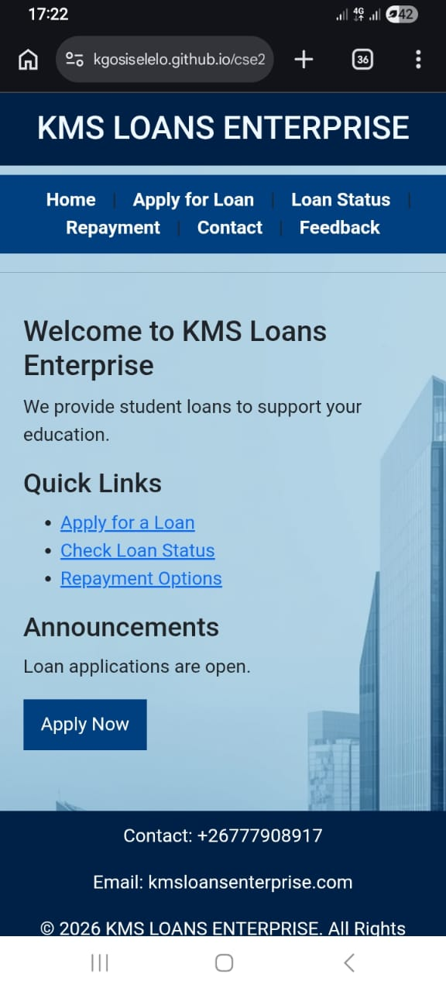
- MICROSOFT EGDE

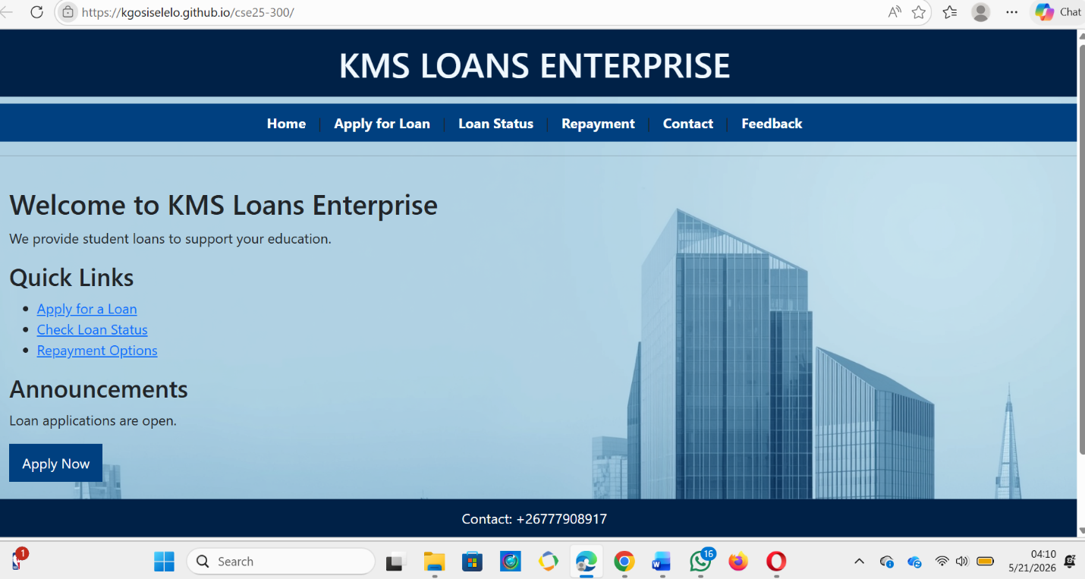

- GOOGLE CHROME

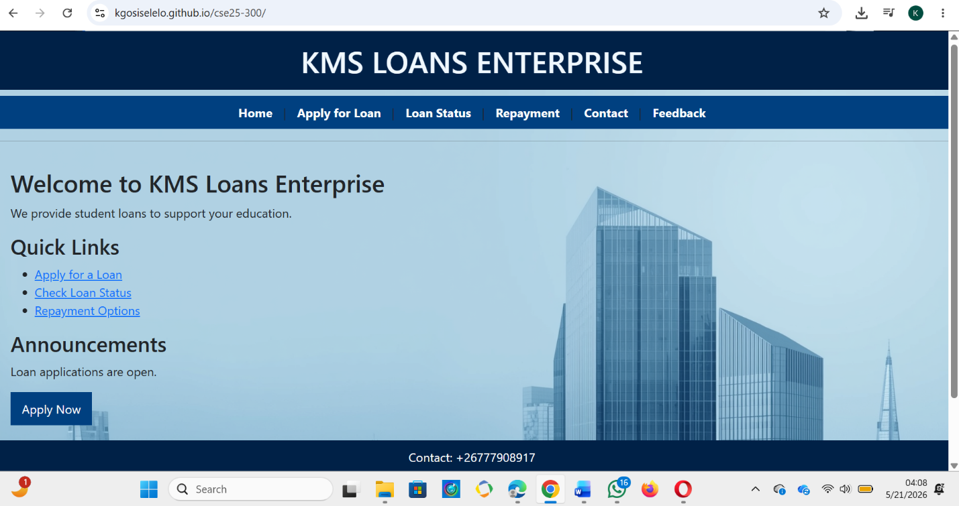

- FIREFOX

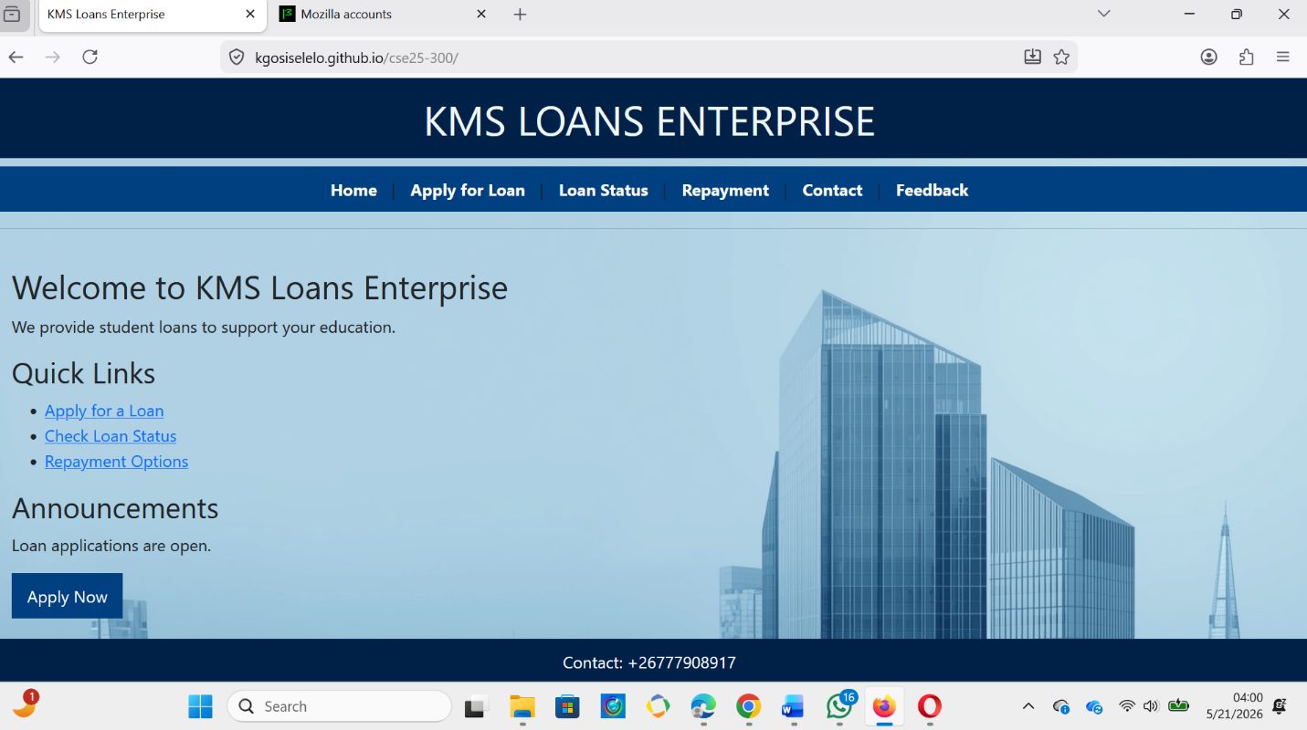

- OPERA

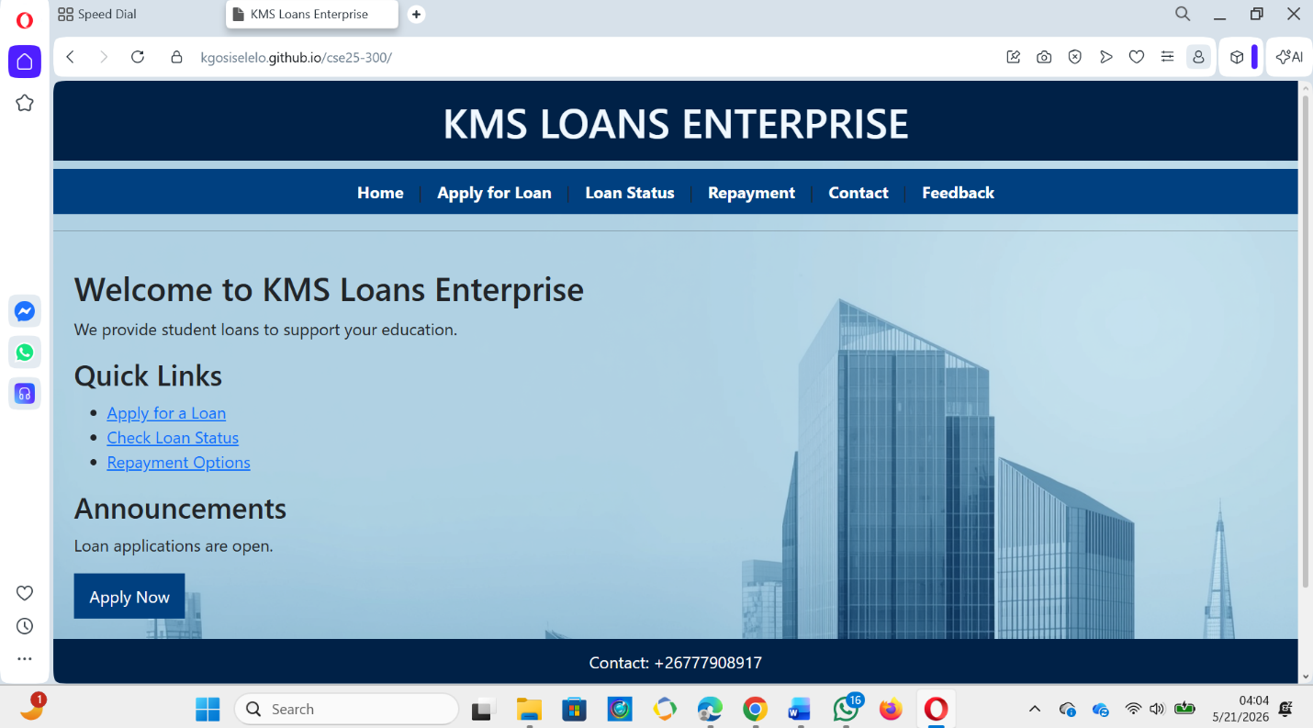

6. PUBLISHING & PROMOTION

Hosting Tools Used
The following tools and technologies were used to host the website:
- GITHUB
- GITHUB PAGES
- Visual Studio Code (VS Code)
- Git Bash / Command Prompt
- HTML5, CSS3, Bootstrap, and JavaScript

GITHUB COMMANDS

Step 1 — Initialize a Git repository
bash
git init

Step 2 — Add all project files
bash
git add.

Step 3 — Commit the files with a message
bash
git commit -m "Initial commit - KMS Loans Enterprise website"

Step 4 — Connect to GitHub repository
bash
git remote add origin https://kgosiselelo.github.io/cse25-300/

Step 5 — Push files to GitHub
bash
git push -u origin main

Step 6 — Enable GitHub Pages
- Go to the repository on github.com
- Click Settings → Pages
- Under "Source", select main branch and click Save
- GitHub generates a live URL automatically

Live Website Link ; https://kgosiselelo.github.io/cse25-300/

7. Future Developments/Recommendations

Accessibility Improvements
To make the website usable by everyone including people with disabilities:
- Add alt text to all images
- Improve color contrast ratios for readability
- Add keyboard navigation support
- Support screen readers using proper ARIA labels

